Gerund Phrase as Head

🟩 What is Gerund Phrase as Head?
# Source: AI Source: Provided by: [Data Path: Persons Table -> ID Column: 1, Name_En Column: Motasem Essam] -> From: [Chatgpt (GPT‑5 Mini)] on [8/7/2025]
A Gerund Phrase is a type of phrase built around a gerund, which is a verb in its -ing form functioning as a noun. In this phrase, the head is the gerund itself.

🔹 Structure of a Gerund Phrase
# Source: AI Source: Provided by: [Data Path: Persons Table -> ID Column: 1, Name_En Column: Motasem Essam] -> From: [Chatgpt (GPT‑5 Mini)] on [8/7/2025]
[gerund] + (optional objects, modifiers, or complements)

Example:
- running a marathon → "running" is the head, and "a marathon" is the object.

🔹 Function of the Head in a Gerund Phrase
# Source: AI Source: Provided by: [Data Path: Persons Table -> ID Column: 1, Name_En Column: Motasem Essam] -> From: [Chatgpt (GPT‑5 Mini)] on [8/7/2025]
The gerund (head) acts like a noun, so the whole gerund phrase can serve typical noun roles:
- Subject
- Object
- Complement

🔹 Examples by Function
# Source: AI Source: Provided by: [Data Path: Persons Table -> ID Column: 1, Name_En Column: Motasem Essam] -> From: [Chatgpt (GPT‑5 Mini)] on [8/7/2025]
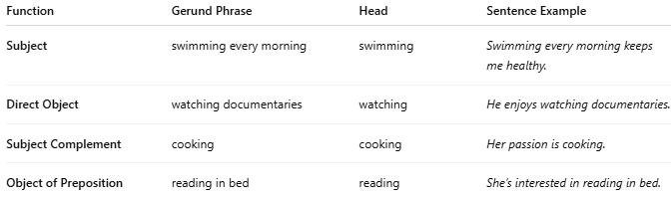
Function | Gerund Phrase | Head | Sentence Example
Subject | swimming every morning | swimming | Swimming every morning keeps me healthy.
Direct Object | watching documentaries | watching | He enjoys watching documentaries.
Subject Complement | cooking | cooking | Her passion is cooking.
Object of Preposition | reading in bed | reading | She’s interested in reading in bed.

✅ Key Points:
# Source: AI Source: Provided by: [Data Path: Persons Table -> ID Column: 1, Name_En Column: Motasem Essam] -> From: [Chatgpt (GPT‑5 Mini)] on [8/7/2025]
- The head of a gerund phrase is always the gerund (a verb ending in -ing, used as a noun).
- The entire phrase behaves as a noun in the sentence.
- A gerund phrase can contain:
  - Modifiers (e.g., adverbs)
  - Objects (e.g., noun phrases)
  - Prepositional phrases

